**Final Report NIKON project: “SIMMO”**

Structured Illumination Microscopy (SIM) Module for Flexible Coupling to Inverted Microscopes - SIMMO

**Subproject Short Description:**

Construction and test of a compact DMD-based structured illumination microscopy module and establishment of the evaluation and control software.

*Benedict Diederich, Haoran Wang, Gerhard Holst, Rainer Heintzmann, Jena 09.11.2022*

# Summary

The stand-alone SIM module produced in the project, which is currently being characterised as a functional sample by means of rapid prototyping processes (3D printing, laser cutting), has two different laser wavelengths (488nm, 635nm) and, in conjunction with a open-source GPU-supported microscopy control and processing software ("ImSwitch", Python) that was co-developed in-house, achieves a final resolution increase of approx. 1.75x compared to classical wide-field microscopy at a field of view of 500x500µm2. The user-friendly software takes care of synchronisation between the camera and the pattern-generating element (DMD), as well as automatic calibration and final processing of the data. An initial characterisation of the reconstructed image quality from the new noise-calibrated compression of the image data developed by PCO suggests a minimal degradation of the image quality. However, the advantage here is the increased speed of imaging.

The focus of the ZIM-funded project "SIMMO", which was successfully worked on jointly by the PCO company and the Leibniz-IPHT Jena research institute, was the development, construction, evaluation and exploitation of a dedicated microscopy module that enables simple optical high-resolution.

The following work packages were formulated:

* Innovative core elements of the SIM are based on low-cost DMDs and light sources.
* Increase of the resolving power by a factor of ~1.8 compared to Abbe resolution-limited microscopy methods.
* Compact design of the SIM module.
* Investigation and creation of a universal, flexibly adaptable opto-mechanical coupling of the SIM light into the stands of the various microscope manufacturers.
* Use of a novel, fast, high-resolution (10 MPixel) and back-illuminated sCMOS image sensor.
* Investigation of the possibility of image data compression methods and their influence on the SIM.
* Investigate the possibility of image data pre-processing and compression using camera specific parameters (such as noise performance) to speed up SIM image data processing.
* Adaptation of the camera software development kit (SDK) to accelerate image data processing.
* Use of GPU in the computer for parallel very fast evaluation and display of the high-resolution images.
* Integration of the SIM evaluation software in open-source GUIs for the control of the SIM module and the display of the high-resolution images.
* Integration of the SIM module control and the camera control into an overall system concept, which should enable the SIMMO system to be used as simply as possible in the application.
* A high-resolution SIM system as a new, cost-effective add-on tool for biological questions in existing inverted microscope systems.

# Detailed (according to the work packages)

## WP1.1 Simulation

### Concept for optics design

Based on the discussions with Douglas Sheppard (University Colorado) and Thomas Huser (University Bielefeld), the optical path was designed for fluorescence excitation using different laser wavelengths. During the experimental validation, it was noticed that the mode of operation of the digital mirror device (DMD) from Texas Instruments (TI) used in this project differs from that assumed in the mathematical model. The display in the TI evaluation kit, which is needed to generate the structured illumination, uses a new form of pixel geometry. Here, the individual elements no longer have an axis of symmetry but, in addition to the tilting of the micromirrors, have a slight rotation at the same time. This has a great influence on the physically correct mode of action of the grating pattern in the sample plane through constructive interference and first had to be theoretically derived within the project and adapted to the pixel position. The team around Douglas Sheppard was of great help in this respect.

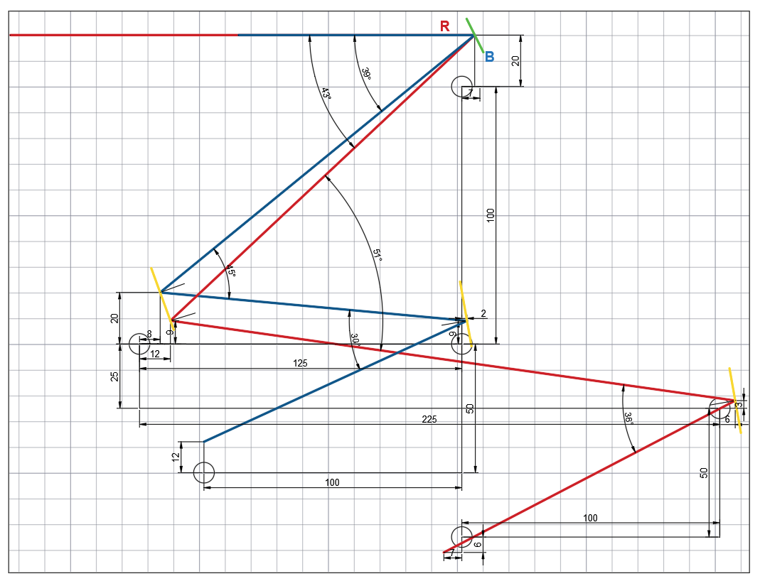

**Figure 1:** Schematic beam path of the SIMMO module with two-colour excitation

The correct beam path with two laser wavelengths (488nm, 635nm) is shown in Figure 1, where a single DMD is used for both wavelengths. An alternative optical configuration, where different wavelengths are each driven by a DMD and combined by means of a dichroic mirror, was not considered economical and practical after initial survey. The optical beamline is the result of an iterative development process, while reducing complexity and cost.

The aim for this generic SIM module was to be compatible with the majority of different microscopy tripods. However, we were lucky to get one Nikon TI-E eclipse inverted microscope to customize and finetune the optical setup. This allowed the beam path to be tested and adjusted on different systems. The advantage of the Nikon microscopy system is the correction of chromatic aberrations in the microscopy objectives, which is advantageous when imaging the grating into the sample plane with several excitation wavelengths. Furthermore, in combination with a supplied adapter, a new type of camera (see following chapters) with an increased number of pixels and an objective with a large field of view, we were able to show how an optical high resolution (>1.7x) can be realised even with an extremely large field of view. This offers the user the advantage of a high sample throughput with simultaneously high optical resolution.

## Estimation of errors

The novel control of the DMD pixel array leads to a loss of efficiency in the arrangement envisaged here. The so-called blaze condition, i.e. the condition where incident and incident angle in interaction with the sawtooth-shaped reflection grating (micromirror tilt angle) provides an optimum of usable reflected light, cannot be achieved for both wavelengths simultaneously and, due to the additionally necessary rotation of the pixels, also globally for a single wavelength. This technical problem only became apparent during the experiments and was modelled by us with mathematical tools. We are currently writing a scientific publication on this topic to document the problem for future setups. This information is of great relevance for future projects/products, as the original form of pixel control is no longer produced by Texas Instruments ("end of life").

## Selection of the fluorophore/laser wavelength

For the validation of correct functioning, we were able to use epithelial cells labelled with immunohistological staining (Alexa Fluor ® 647, anti-tubulin) within the project. For this purpose, excitation of the samples was achieved using fibre-coupled lasers (488nm, 635nm). For cost optimisation, experiments were carried out with different devices, whereby Chinese diode lasers (MICOST, Wuhan, China) were compared with German devices (Omicron, Germany) with regard to phase stability, mode profile, temporal spectral stability and output power. Furthermore, multi mode and single mode lasers were compared. The final choice in terms of price and mode quality was a combination of two MICOST fibre-coupled single mode lasers. Alternative experiments with multi-mode lasers requiring higher power were abandoned because the effort for the so-called despeckling was too high. The devices from a Chinese manufacturer offer a cost advantage of a factor of ~20x, whereby the optical quality was not noticeably impaired within the project duration.

The impaired efficiency to generate the structured illumination due to the non-observance of the blazed condition and the increased exposure time due to the limited laser power of ~50mW, also affects the maximum imaging speed. Camera imaging rates of live cell experiments are thus limited to the maximum signal-to-noise ratio that can be achieved. Here, synthetic fluorophores (Alexa Fluor 647) have had a positive effect on reconstruction quality and imaging speed due to their increased signal level (e.g. emitted photons). The camera used within the project (PCO.Edge 4.2) has an increased frame rate compared to the camera also provided (PCO Edge 26) with a smaller pixel size. The maximum data rate was not a limiting factor in our experiments, so the initially envisaged increase in the imaging rate with the aid of image compression could not offer any advantage, since the recording rate was limited by the available laser power. However, this could be circumvented by using higher intensity lasers.

### Problems in the supply chain

Due to the delivery problems associated with the corona pandemic for some elementary electronic components (e.g. adapter board for DMD), as well as delays in the delivery of the new camera on the part of PCO, not all work packages could be processed to the full extent by the end of the project. However, it is worth mentioning that the solutions developed for new problems will be used to a large extent in the design of future projects. Above all, the modelling of the new DMD type with rotation-tilt mirrors should be mentioned here.

## WP1.2 Verification

### Experimental verification of the simulated results

For the initial prototyping of the later SIMMO module on the Nikon microscope, a special openSIM module was first built for the openUC2 system developed at Leibniz-IPHT (https://github.com/openUC2/UC2-GIT) (see Figure 2). Using rapid prototyping methods such as 3D printing in conjunction with widely available components such as the Raspberry Pi and a smaller DMD mirror array, a first compact functional model was built on which both the algorithms and the alignment methods were developed and tested. The results of this work are made openly available (https://github.com/openUC2/UC2_openSIM) and are described in a publication in Royal Society Transactions A [1,2].

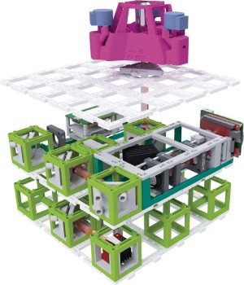

**Figure 2.** 3D representation of the openUC2 SIM setup. The microscope consists of 3 functional layers: Detection, Excitation and Sample Positioning. The SIM illumination pattern is generated by a small low-cost DMD.

Furthermore, the results were presented within a workshop at the SIMPosium organised by the Royal Society [London 02/2022].

The results from the rapid prototyping study can be seen in Figure 3.

In this sub-project, only low-cost components were used (industrial machine vision camera, video projector). A quantitative analysis regarding the optical resolution shows a resolution gain of a factor of 1.75 for the Nikon system with PCO camera compared to the openUC2 system with a factor of approx. 1.4.

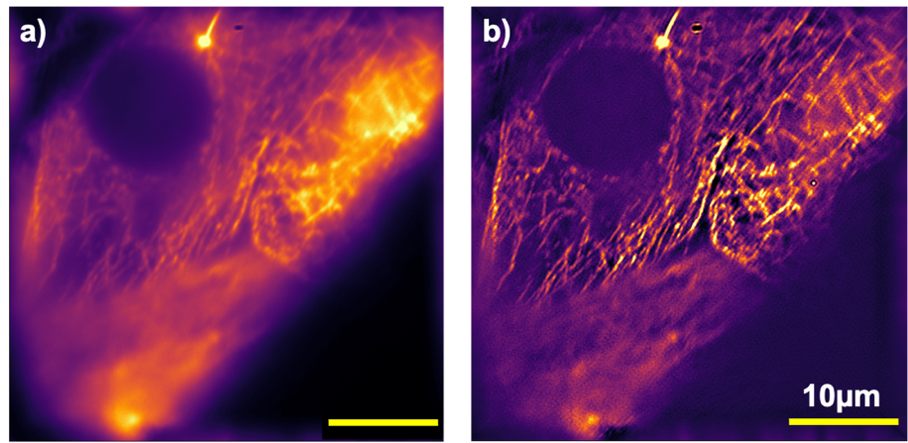

**Figure 3:** The result with the openUC2 system. The microtubules of the HeLa cell are stained with the dye Alexa Fluor ® 647. The excitation is done with a 635nm diode laser. The resolution after SIM reconstruction is 180nm and an enhancement power of factor 1.4.

## AP 1.3. prototype/functional model

The optical setup outlined in Figure 1 was first attached to the existing Nikon tripod using standard optical components (Thorlabs) on an optical table. An iterative process followed, optimising both the complexity of the setup and the efficiency of the diffraction pattern. Based on the final optical relationships, a CAD model was derived, which was converted into a module that could be easily mounted on different types of microscopes. The housing was manufactured by laser cutting. Additional components to increase stability at mechanically relevant points were achieved by using standard parts or 3D printing. The result is a stand-alone module, which is available as a functional model in the optical laboratory of the Leibniz-IPHT cooperation partner.

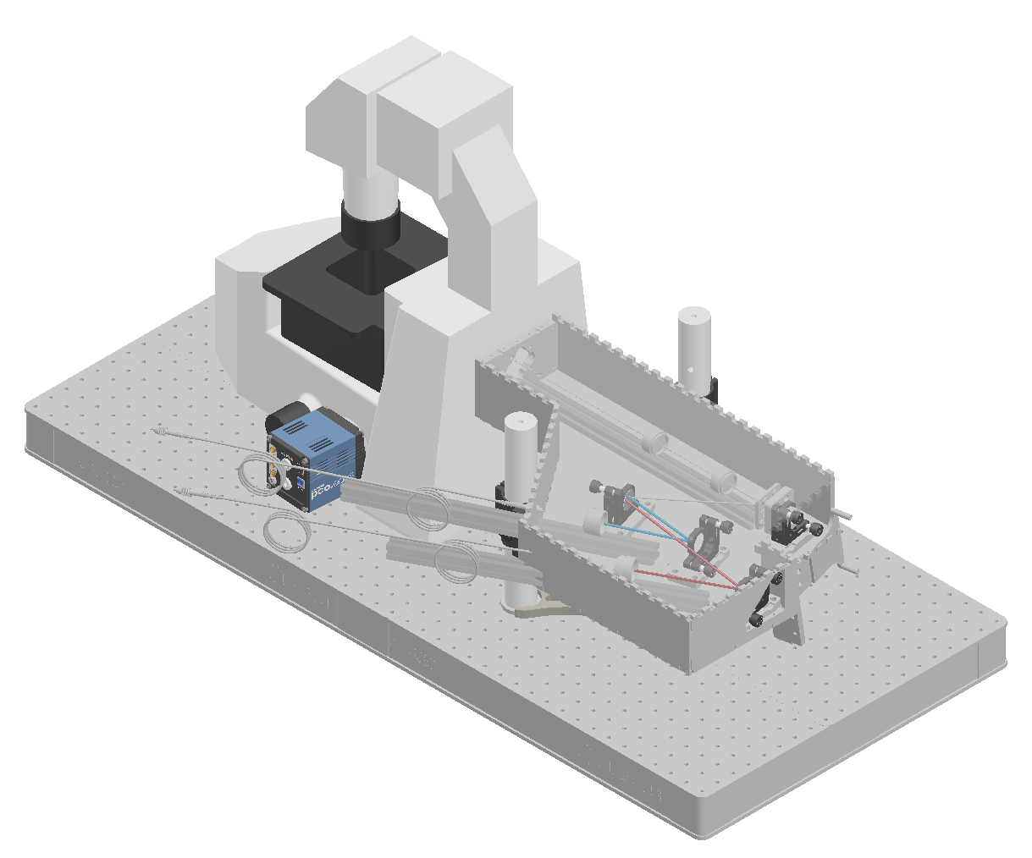

**Figure 4.** 3D CAD rendering of the SIM illumination module on the Nikon microscope.

The low-cost evaluation board for generating the structured illumination has only a limited range of functions. During the course of the project, it became apparent that the video memory available on the evaluation board was not sufficient to temporarily store the necessary SIM patterns. For this purpose, FPGA-based electronics (M5Stack, Atom Display, China) were developed to provide a triggerable video source. To synchronise the electronics (laser, illumination patterns) with the camera, a modular approach was adopted from the openUC2 project, with the results also being available in open source (<https://github.com/openUC2/UC2-REST>).

AP 1.4. completion

Testing the function of the SIM module for Zeiss and Olympus microscopes

Due to the easier integration of the optical setup into Nikon microscopes and the offer from Nikon to provide a loan unit for the duration of the project, the decision was made to first develop the module for integration into this microscopy system. In the following, we present the measurement results on biological samples and compare them with conventional wide-field microscopy.

### Functional test on biological samples

The measurements were performed on microtubules of HeLa cells stained with Alexa Fluor ® 488. The results compared in Figure 5 show a significant improvement in terms of "optical cutting" (axial resolution) and a gain in lateral resolution of up to a factor of 1.75. The optical resolution classical widefield is given as 520nm and in the SIM reconstruction as 298nm. This results in an improvement by a factor of 1.75.

In the measurements, a 20x/0.75 lens was used in combination with the PCO Edge26 camera.

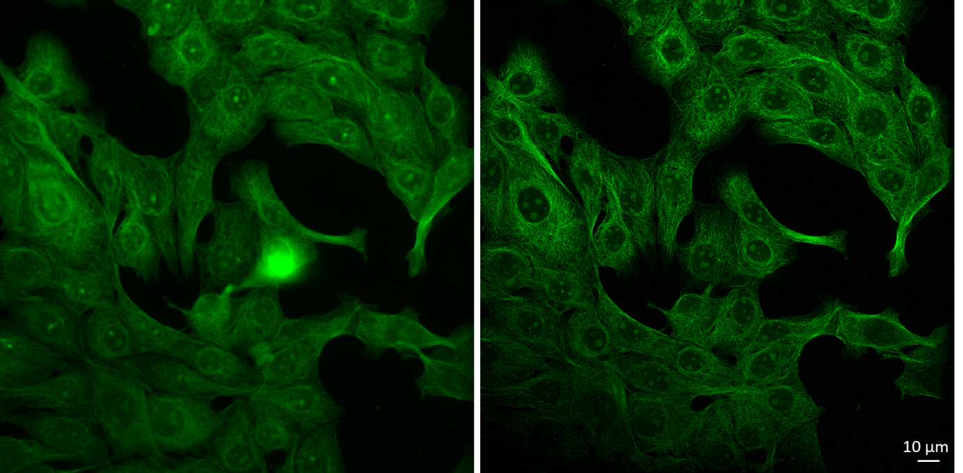

**Figure 5:** First result with 20x/0.75 lens and the PCO.edge26 camera. A large field of view is obtained with high axial and lateral resolution at the same time. Left: Wide field, right: SIM reconstruction.

Figure 6 shows the result from a sample (Cos-7 cells) with several dyes. The experiment was performed with a Nikon 60x/1.4 oil immersion lens and the PCO.edge 4.2. Mitochondria and actin are stained with AF488 and Silicon Rhodamine respectively. The left side shows the result of the classical wide-field microscopy, whereas the right side shows the reconstructed SIM image. The resolution was determined by decorrelation analysis. The SIM resolution of 161nm and 203nm of the reconstructed red and green channel is about a factor of 1.55 to 1.65 better compared to the corresponding wide-field resolution of 249nm and 334nm.

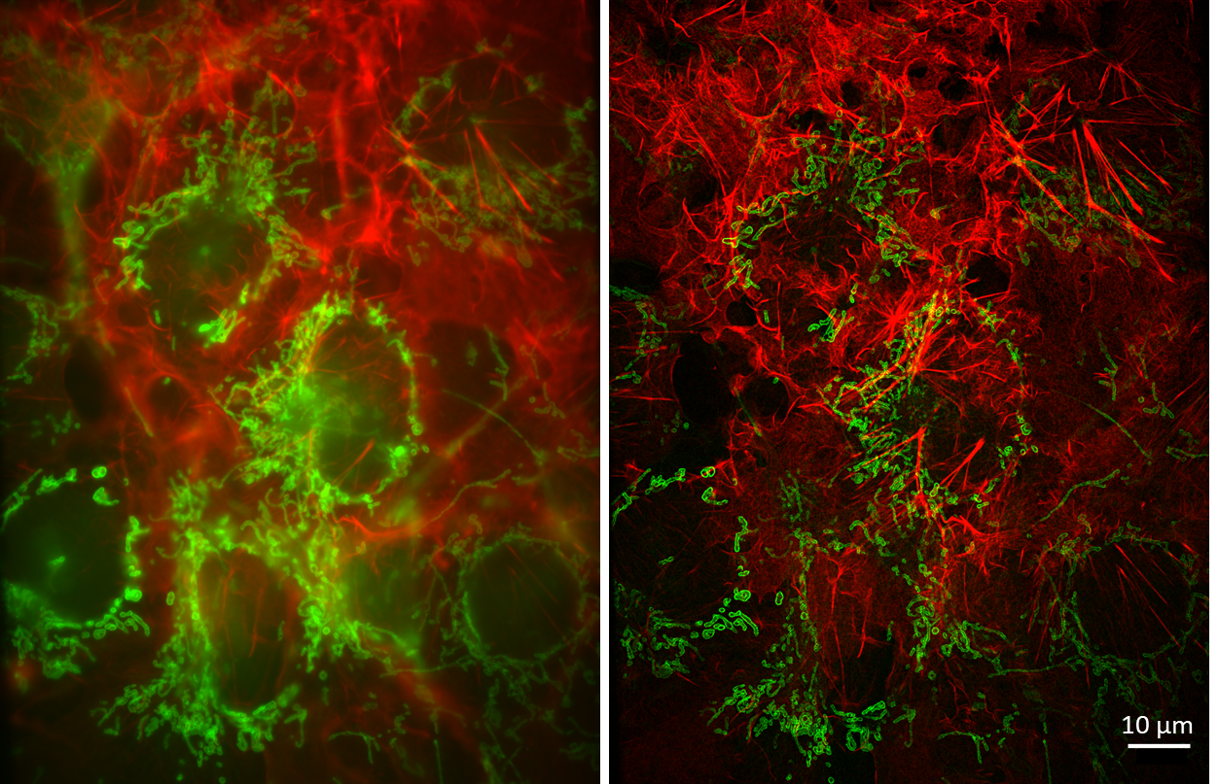

**Figure 6.** two-colour image of Cos-7 cells. Left: Wide field, right: SIM reconstruction.

## Compression method

The compression method developed by PCO can increase the camera frame rate by transferring less data, but the optical quality is not significantly affected. In order to test the functionality of this new algorithm on SIM data, PCO first decompressed the data and reconstructed it using SIM software. Figure 7 compares the reconstructed raw data (left) with the data compressed to 8 bits (right). The signal-to-noise ratio after data compression has slightly decreased. In general, the data seems to retain much of the high spatial frequencies of the sample information. A deeper quantitative analysis is still pending.

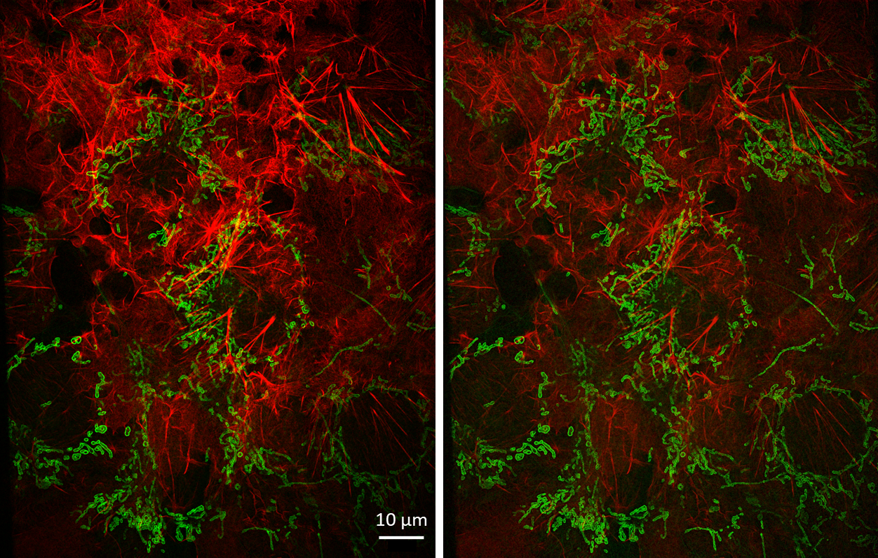

**Figure 7.** evaluation of the compression process. Left: Raw data from camera, right: 8 bit compression.

## WP 4.1 Development of a suitable GPU based reconstruction software

For the reconstruction of the data, a new Python based user interface for the synchronisation of the devices (SLM, camera), as well as for the reconstruction of the data was adopted from open source repositories (Github) and further developed for the purpose of the SIMMO project. The software "ImSwitch" combines a robust software environment with the possibility of reconstructing the data recorded with the microscope using a GPU. In contrast to the initially planned software "Fiji" or "FastSIM", the Python-based software could be independently adapted to the SIMMO structure, as the corresponding developer know-how was available at the IPHT. Open source libraries such as "Cupy" and "PyTorch", which enable fast processing of the data on the GPU, were integrated into the user interface in connection with the "SIM Processor" for Napari. A calibration of the data regarding the illumination pattern was also automatically taken over by the software, so that the system can be operated more easily by the user. The software is still in the development phase and will be made available to the scientific community in the form of a scientific publication within 2022. This includes real-time processing of the data and easy installation.

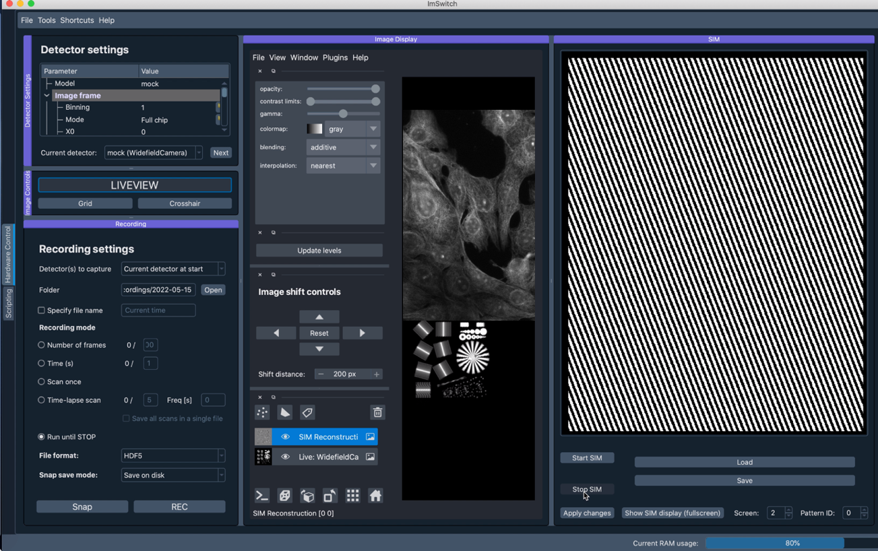

**Figure 8** shows the user interface that handles both camera/device control and reconstruction.

## AP 4.2 Control of the SIM module via open-source GUI

By integrating the SIMMO module into the software "ImSwitch", a synchronisation between image acquisition and hardware control was also achieved. The SIM patterns (3 phase, 3 rotation angles) are calculated in advance and output and displayed on the DMD via the HDMI port using a graphics card output. Together with the Python-based camera library provided by PCO, a camera adapter was written that ensures fast image readout. Due to the restrictions on the part of the display electronics to keep SIM patterns in memory, the maximum display frequency achieved was limited not only by the exposure time, but also by the display rate of the projector (approx. 30 Hz). Furthermore, the evaluation board from Texas Instruments does not have a trigger input. To solve these problems, an FPGA-based (Field Programmable Gate Array) video driver was developed, which on the one hand synchronises the image output of the SIM patterns with the camera and on the other hand achieves a faster frame rate.

Due to the delay in the delivery of the new back-illuminated cameras by PCO, it has not yet been possible to record data with the PCO Edge sCMOS camera. Independently of the project, which is now coming to an end, we will continue the data acquisition and publish it in the form of a scientific publication. This includes the complete analysis and characterisation of the noise-equilibrated compression techniques for suitability of use in image processing of SIM microscope image data.

The company PCO was bought out by Excelitas within the project period, which led to a change in company planning aspects and some delays.

For a production of the functional model built at Leibniz-IPHT, some, significant tests and, if necessary, changes regarding the points: Laser protection, EMC, product safety and user-friendliness, before a then manufactured prototype is ready for the market.

[1] Wang, H., Lachmann, R., Marsikova, B., Heintzmann, R. and Diederich, B., UCsim2: two-dimensional structured illumination microscopy using UC2, Phil. Trans. R. Soc. A. (2022), http://doi.org/10.1098/rsta.2020.0148.

[2] Diederich, B., Lachmann, R., Carlstedt, S. et al. A versatile and customizable low-cost 3D-printed open standard for microscopic imaging. Nat Commun 11, 5979 (2020), https://doi.org/10.1038/s41467-020-19447-9.

[3] Müller, M., Mönkemöller, V., Hennig, S. et al. Open-source image reconstruction of super-resolution structured illumination microscopy data in ImageJ. Nat Commun 7, 10980 (2016) https://doi.org/10.1038/ncomms10980.

[4] Schermelleh, L., Heintzmann, R., and Leonhardt, H., A guide to super-resolution fluorescence microscopy, The Journal of Cell Biology, 190 (2010), https://doi.org/10.1083/jcb.201002018.

[5] Sandmeyer, A., Lachetta, M., Sandmeyer, H., Hübner, W., Huser, T., Müller, M. Cost-Effective Live Cell Structured Illumination Microscopy with Video-Rate Imaging, ACS Photonics, 8 (2021), https://doi.org/10.1021/acsphotonics.0c01937.